



kurs
sertifikati
Sertifikat
Ushbu shu haqdakim
Xushnudbek Jumaboyev
Mohirdev platformasida qisqa
45 Minutda HTML5
kursini muvaffaqiyatli tugatdi
Mohirdev ta’lim platformasi rahbari
17.09.2026
ID prac-154ae5a9

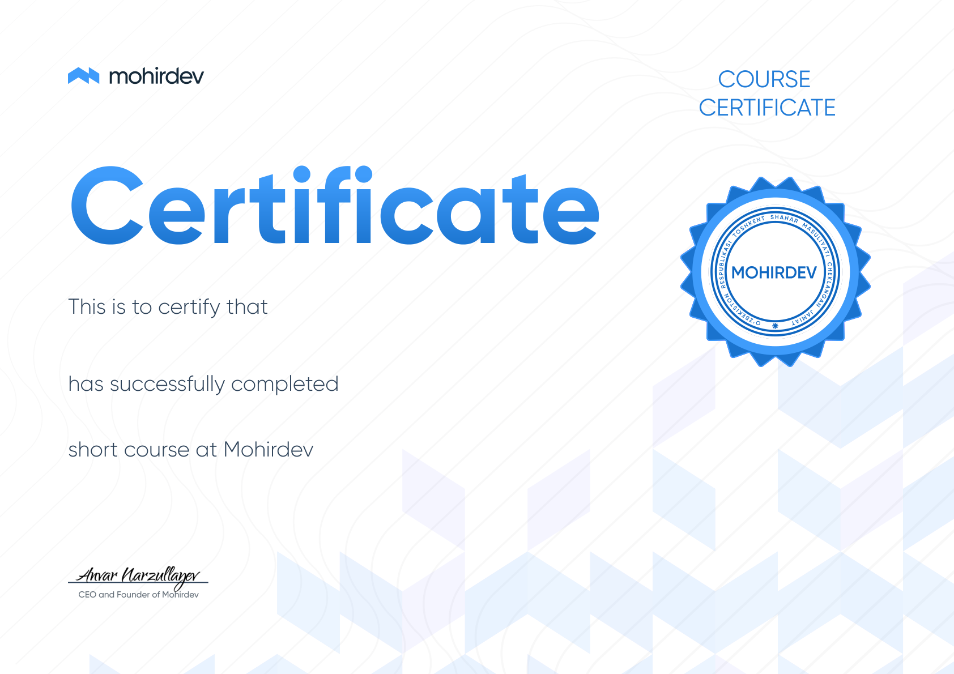
course
certificate
Certificate
This is to certify that
Xushnudbek Jumaboyev
has successfully completed
45 Minutda HTML5
short course at Mohirdev
CEO and Founder of Mohirdev
17.09.2026
ID prac-154ae5a9

